WESTERN PACIFIC UNIVERSITY
CMN224 / CMP224 Software Engineering — Week 9
Lab 6: Behavioural Diagrams for Your Client
Formative (ungraded) · Moodle-enabled · completes the modelling half of Task 4 (15%, due Week 11)
Item | Details
Linked to | Week 9 lecture — Behavioural UML and the 4+1 view model (ULO2, ULO4)
Work mode | Individually, on the SAME client you used for Task 2 and Lab 4
Time | About 90 minutes
Tools | diagrams.net desktop OR PlantUML — free, offline, both cached on Moodle
Submission | Four diagrams + this worksheet to Moodle AND committed to week09/ in your portfolio
This finishes Task 4. Task 4 (Design & Modelling Deliverable, due Week 11) asks for a use-case model, a class diagram, state and activity diagrams, an outline architecture and one applied design pattern. Lab 4 gave you the architecture. Today gives you the four diagrams. Week 13–14 supplies the pattern.
Part A — Use case diagram (20 min)
Show the actors, the system boundary and 5–9 use cases. Each use case is a goal in the actor's language, not a screen or a button.
# | Check before you move on | Done
1 | Every actor is a ROLE, not a named person | Actors: Students, Lecturers, Administrators
2 | Every use case is a goal (a verb phrase the client would recognise) | Student: Register of course, view course schedule, submit assignment and view grades.  Lecturer: Upload Assignments and Tests, record student grades.  Administrator: Generate reports, manage student records
3 | The system boundary is drawn — it is clear what is outside | Large rectangle containing all the use cases.
4 | Every use case traces to a user requirement in your SRS | The system shall allow students to register for courses.  The system shall display enrolled course schedules.  The system shall support online assignment submission.  The system shall provide access to student grades.  The system shall enable lecturers to upload learning resources.
PlantUML starter
@startuml
left to right direction
actor Bursar
actor "Head teacher" as Head
rectangle "Fee System" {
Bursar --> (Record payment)
Bursar --> (Issue receipt)
Head --> (Approve refund)
}
@enduml

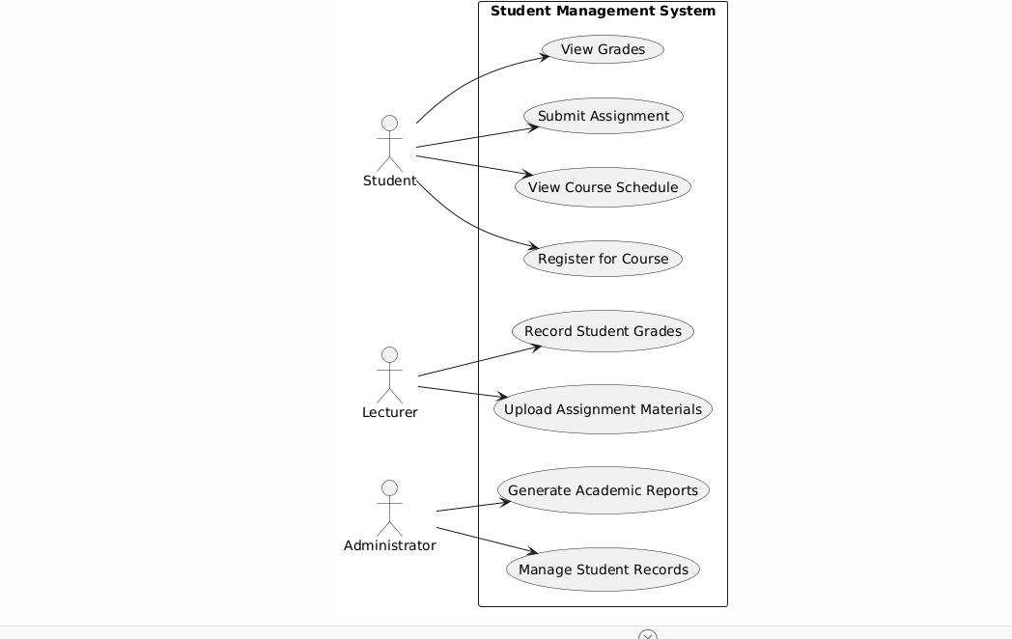
Figure 1.1. Displaying the drawn UML Snapshot.
Part B — Class diagram (25 min)
Show 4–7 classes with attributes, key operations, named associations and multiplicity. Read your SRS: recurring nouns are candidate classes.
# | Check before you move on | Done
1 | Every association is NAMED (pays, generates, approves) | Course, student, lecturer, assignment, grade, report and administrators.
2 | Multiplicity is shown at both ends | Multiplicity is the relationship that exist between two groups.
3 | At least one multiplicity encodes a real business rule from Week 2 | - A Student registers for 1..* Courses, each Course has 0..* Students  - A Lecturer teaches 1..* Courses, each Course is taught by 1 Lecturer  - A Course has 0..* Assignments, each Assignment belongs to exactly 1 Course  - A Student submits 0..* Assignments, each Assignment can be submitted by many Students  - A Grade belongs to 1 Student and 1 Assignment
4 | No attribute exists that your SRS never mentions | Student - Attributes: studentID, name, email  Lecturer - Attributes: lecturerID, name, email  Course - Attributes: courseID, courseName, schedule  Assignment - Attributes: assignmentID, title, dueDate
PlantUML starter
@startuml
class Student {
- studentId
- termFee
+ outstandingBalance()
}
class Payment {
- amount
- method
}
Student "1" -- "0..*" Payment : pays
@enduml
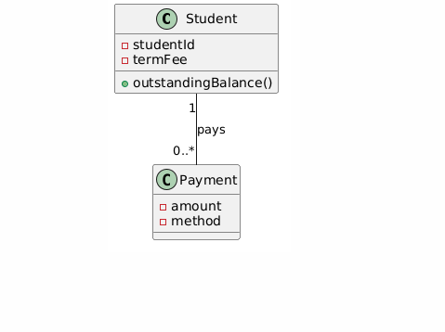
Figure 1.2. Displaying the snapshot of the UML Diagram
Part C — State diagram (20 min)
Pick ONE thing in your system that has a genuine lifecycle — a payment, an intake record, an application. Show its states, the triggers between them, and at least one guard.
The lifecycle begins at the "New" state, representing an application that has been submitted but not yet reviewed. The transition to the "Under Review" state is triggered by the "Submit Application" action, which initiates the administrative workflow.
Once in the "Under Review" state, the system evaluates the applicant's credentials to determine eligibility. The transition to "Accepted" is triggered by the "Approve" action, which is protected by the guard [GPA >= 3.0], ensuring that only qualified candidates proceed.
If the application is approved, the system moves to the "Enrolled" state, which serves as the successful end state. Conversely, if the application fails to meet the requirements or is withdrawn, it transitions to the "Rejected" or "Cancelled" end states, respectively.
# | Check before you move on | Done
1 | Every state is a CONDITION, not an action | By ensuring states represent conditions, your model correctly captures the "status" or "situation" of an object rather than just a process step.
2 | Every transition names its trigger | Naming your triggers ensures that the model clearly defines the cause for every change, which is vital for system logic.
3 | At least one guard [in brackets] encodes a business rule | Including guards in brackets allows you to enforce business rules, ensuring the system only transitions when specific criteria are met.
4 | There is a start state and at least one end state | Having a start state and an end state ensures that the lifecycle of your object is fully defined from inception to completion.
PlantUML starter
@startuml
[*] --> Recorded : record
Recorded --> Receipted : print
Receipted --> Reconciled : match
Reconciled --> Refunded : [head teacher approves]
Reconciled --> [*]
@enduml
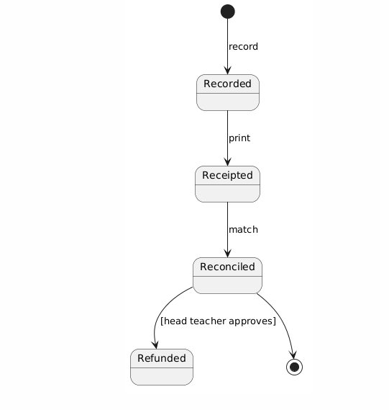
Figure 1.3. Displaying the drawn UML Diagram
Part D — Activity diagram with swimlanes (20 min)
Model one workflow that crosses a boundary in your Week 5 deployment diagram. It must include a branch for what happens when the network or power is unavailable.
The workflow is modelled as a sequence starting with a user input, followed by a decision node for network connectivity. The "Online" path leads to server-side processing with duplicate-safe validation. The "Offline" path allows for local caching of data, which is subsequently processed through the same duplicate-safe validation logic upon reconnection to ensure data integrity.
If the network or power is unavailable, the workflow branches to the Local Cache/Offline Mode process. In this state, the staff member continues to input data, which is stored in a local encrypted buffer on the client device. The system provides a visual indicator that the user is in "Offline Mode." Once the network or power is restored, the workflow triggers a synchronization process. During this synchronization, the Duplicate-Safe Handling logic is applied again to the locally cached data to ensure that any records created or modified during the outage do not conflict with existing entries in the central database before they are finalized. Once the sync is verified as successful, the local buffer is cleared, and the workflow returns to the standard online state.
# | Check before you move on | Done
1 | Swimlanes match the devices/roles in my deployment diagram | Ensure that every actor or system component identified in your deployment diagram (e.g., "Mobile Client," "Local Server," "Cloud Database," "Admin Staff") has a corresponding vertical or horizontal lane in your activity diagram. Any process step must be contained within the lane of the entity responsible for executing that action.
2 | There is a decision node for the offline case | Place a decision diamond immediately following any action that requires network connectivity. One path should lead to the "Online" success flow, while the other leads to an "Offline/Disconnected" flow. This node must explicitly check the status of the connection (e.g., "Is Link Active?").
3 | The workflow shows what staff can still do while the link is down | Within the "Offline" path, detail the specific tasks that remain functional. This typically involves local caching or queuing of data. For example, staff should be able to "Capture Data Locally" or "Queue Transaction," ensuring the system does not simply halt but transitions to a degraded mode of operation.
4 | Duplicate-safe handling appears where data is imported | At the point where the offline data is synced back to the main system, include a process step for "Reconciliation" or "Deduplication." This step must verify unique identifiers (such as timestamps or UUIDs) to ensure that data captured during the offline period does not overwrite or create redundant entries when the connection is restored.
PlantUML starter
@startuml
|Depot laptop|
start
:Record intake;
:Queue change;
if (signal available?) then (yes)
:Send batch;
|Town office|
:Import, skip duplicates;
else (no)
:Hold in queue;
endif
stop
@enduml
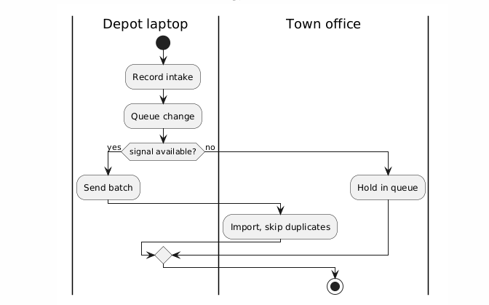
Figure 1. 4. Showing the drawn diagram from the UML
Part E — Commit (5 min)
- Save all four diagram files into week09/ in your portfolio.
Git add week09/
git commit -m “Add use case, class, state and activity diagrams”
AI use: you may generate PlantUML drafts, but you must validate every diagram against your own SRS using the five checks from the lecture. Generated models routinely omit the offline branch and the approval chain — the two things that matter most here. Declare AI use in your README.
AI Use: It was basically used to get ideas and understand the concept of the activity. The hard parts were broken down correctly for an understanding.

